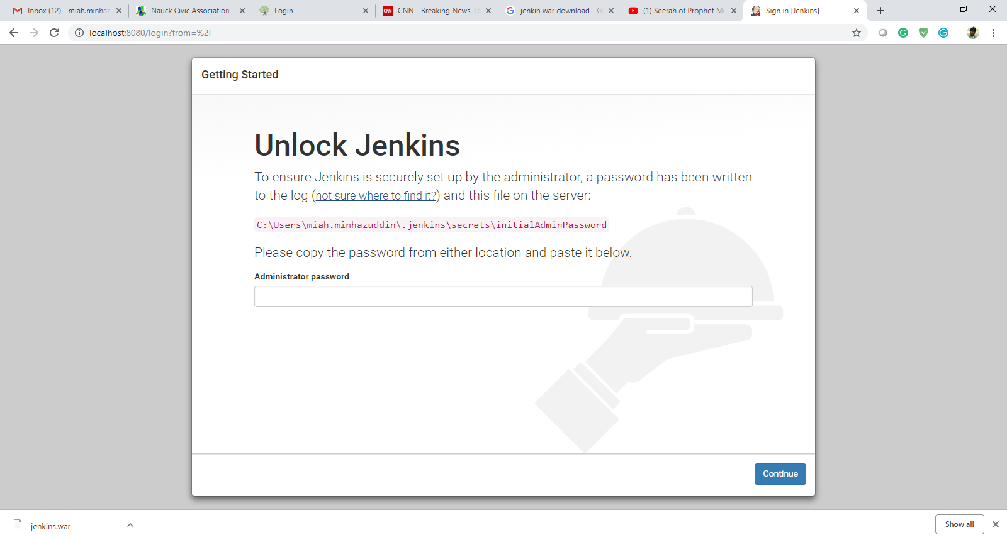

C:\Users\miah.minhazuddin\.jenkins\secrets\initialAdminPassword

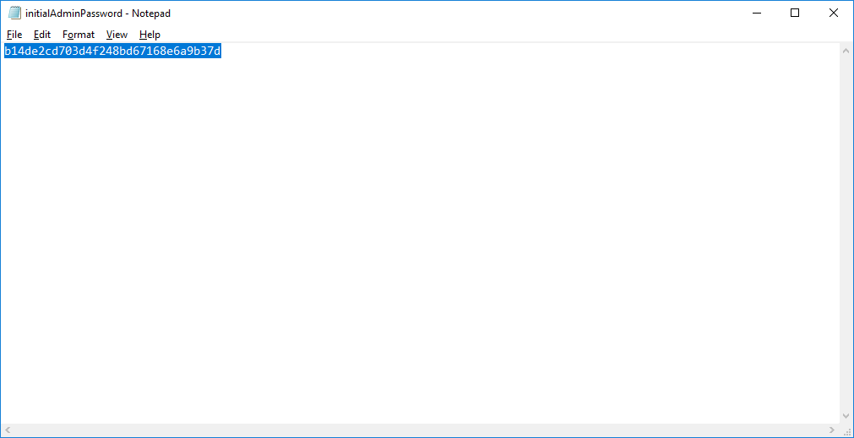

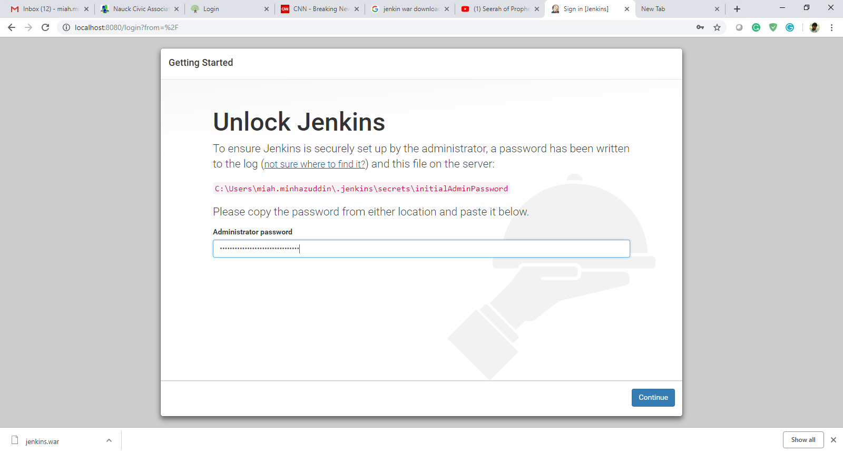

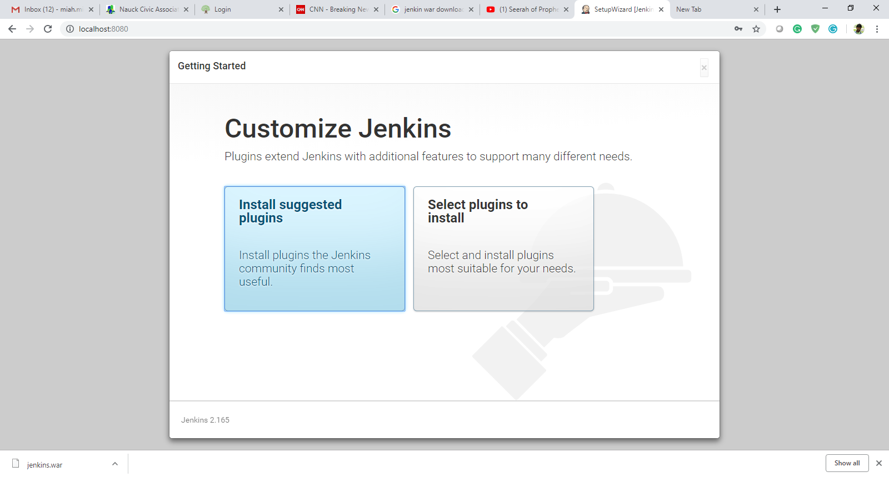

**You will need to get your accounts enabled for extended hours trading. This requires us to read a couple disclosures with you. Please give us a call at 800-544-6666 so we can go through the regulatory disclosures and get it set up for you.**

**We have to read the disclosures to you verbally over a recorded line.**